
Sacred Heart Catholic School
SPREADING GOD’S LOVE SINCE 1882

313 S. Texana St., Hallettsville, TX 77964 361-798-4251 www.shschool.org
The Mission of Sacred Heart Catholic School is to teach Gospel values that will foster the spiritual,
moral, academic, social, and physical growth of the students according to Catholic tradition
and the spirit of the Sisters of the Incarnate Word and Blessed Sacrament.

ALUMNI NEWSLETTER 2017

FROM THE PASTOR’S DESK
Thank you to the Sacred Heart Parish and the Hallettsville community and others for helping us to celebrate our 135th anniversary as we begin a new school year here at Sacred Heart Catholic School. We are grateful to the Incarnate Word & Blessed Sacrament Sisters and Father Anthony Forest for their foresight in establishing our parish school.
We are all off to a great start. Mr. Kevin Haas , our principal, is beginning his third year as principal and is doing a great job. We are blessed to have him and our wonderful teachers and staff.
It makes me feel proud to hear good reports about our graduates when they go off to college or other endeavors. We get many glowing reports about our students.
Sacred Heart Catholic School provides a well-rounded education for our students. They have a faith based education and are offered excellent academic and extra-curricular activities as well as many spiritual opportunities.
Thank you to all our alumni for your prayers and support. Due to your love and generosity we are able to keep our school going and to keep it viable as a top quality Catholic school. With your continued support, we look forward to a great future for many years to come. Help spread the good news!
God bless you and feel free to come by the school anytime and check out our facilities and our great students, teachers and staff.
Rev. Msgr. John C. Peters, Pastor

FROM THE PRINCIPAL’S DESK
Last year Sacred Heart completed 135 years of Catholic Education. The Sacred Heart Catholic School Class of 2017 consisted of 32 young adults ready for the next journey in life.
We had a very eventful year with many great student accomplishments. One of the greatest was the State Band Championship. The 63 band members brought home the back to back State Championship. There were many other exciting times throughout the year and we are very proud of the students, staff and coaches for a great year.
The 2017-18 school year started out great with many exciting events. There are many new activities this year so be sure to connect with us on Facebook or on the school website.
Thank you to everyone who helped out this past year with the Annual Fund. We’ve collected a record amount because of your generous support. With the rising cost of educational needs, salaries, books and materials, the Annual Fund helps defray these rising costs while trying to keep tuition affordable for our parents.
Please take note of this year’s Homecoming schedule. Because of scheduling issues, there are changes in the sequence of events. The pep rally will be on Sunday, October 22nd at 5:00 in the gym to kick off Homecoming week. The Homecoming game will take place on Thursday October 26th at 7:30 pm. The Memorial Mass will be on Saturday October 28th at 3:00 at the Sacred Heart Catholic Church with the social, meal and dance to follow at the KC Hall. The Mass will cover your Sunday service obligation. We hope to see you all rooting on the Indians this year at our Homecoming Festivities!

Here are some snapshots of the great things we are doing at Sacred Heart Catholic School!
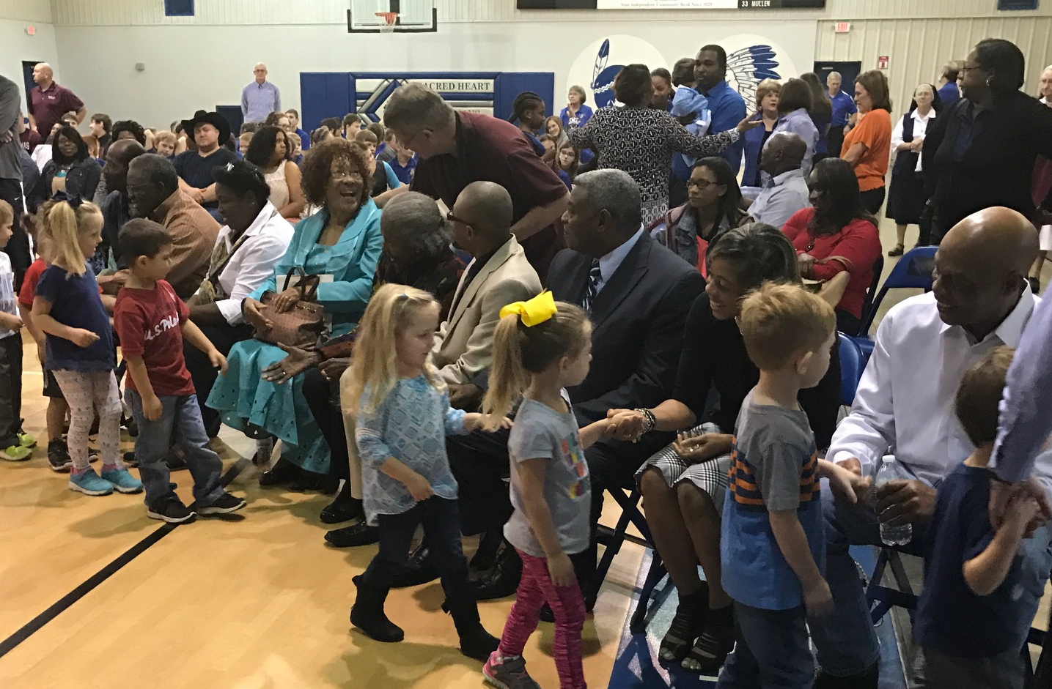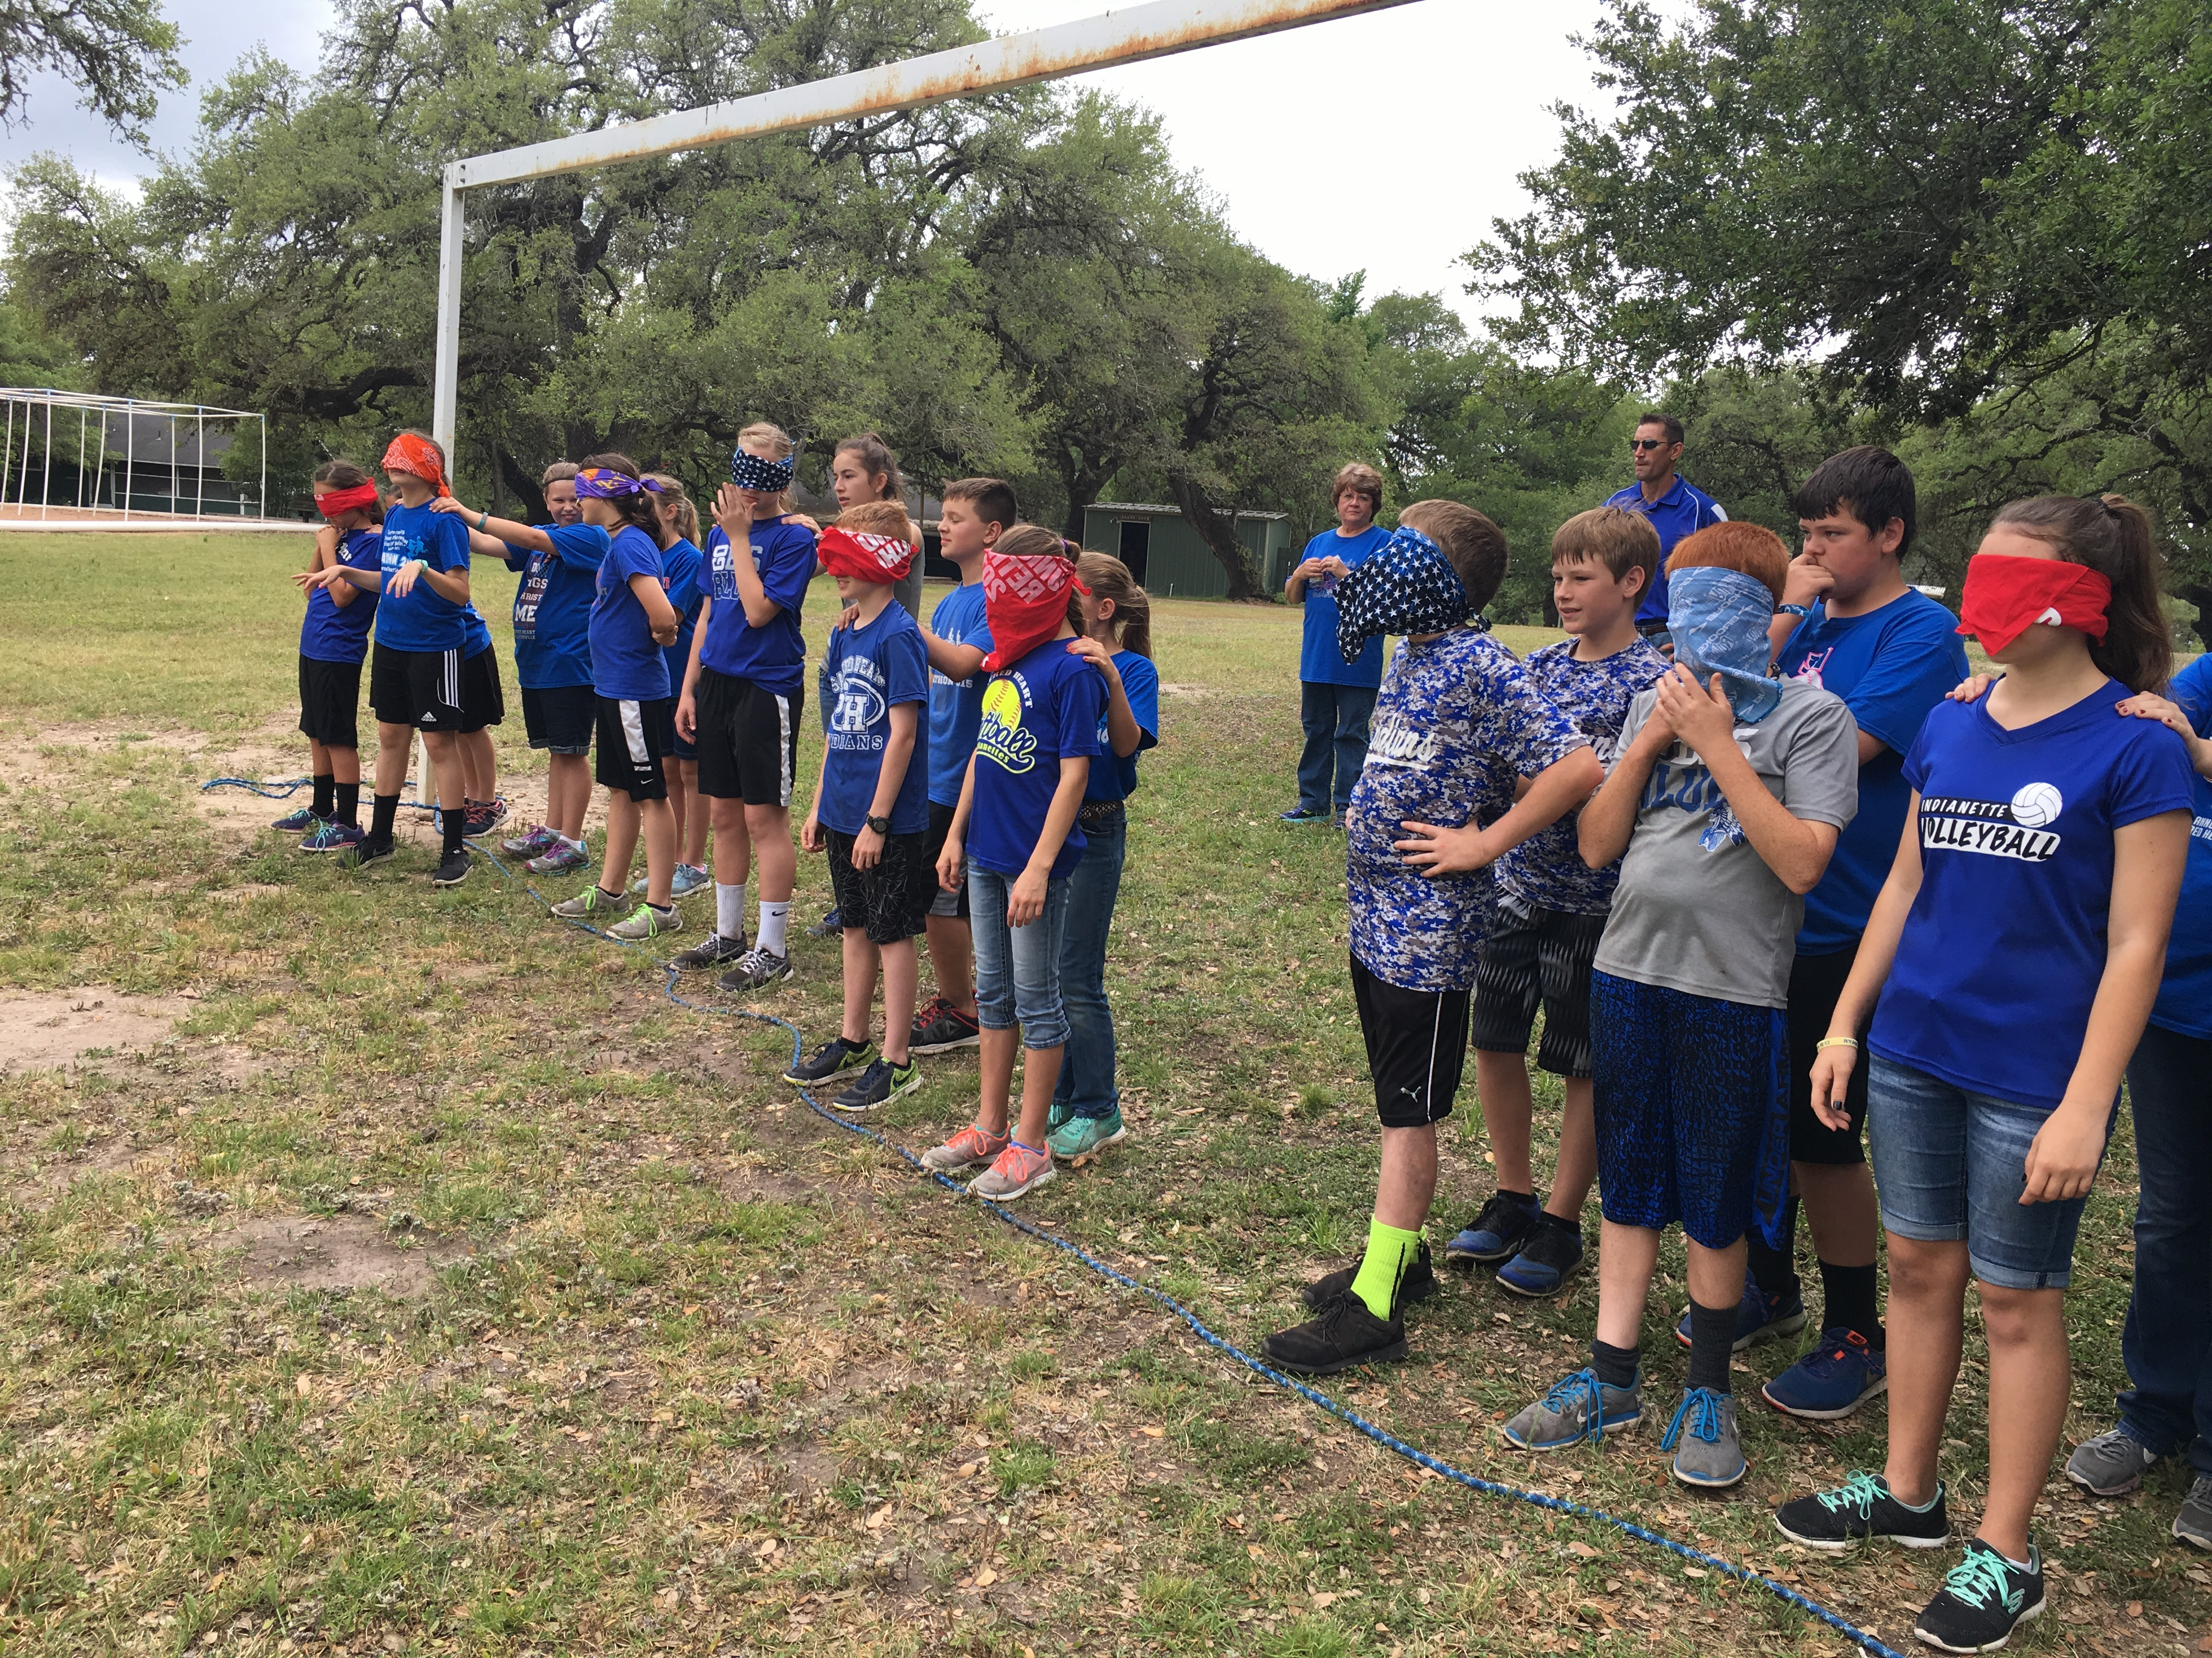
Martin Luther King Day Program - Greeting Our Guests Fun and Educational Field Trips
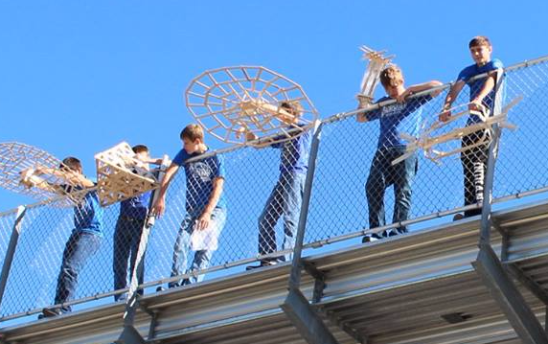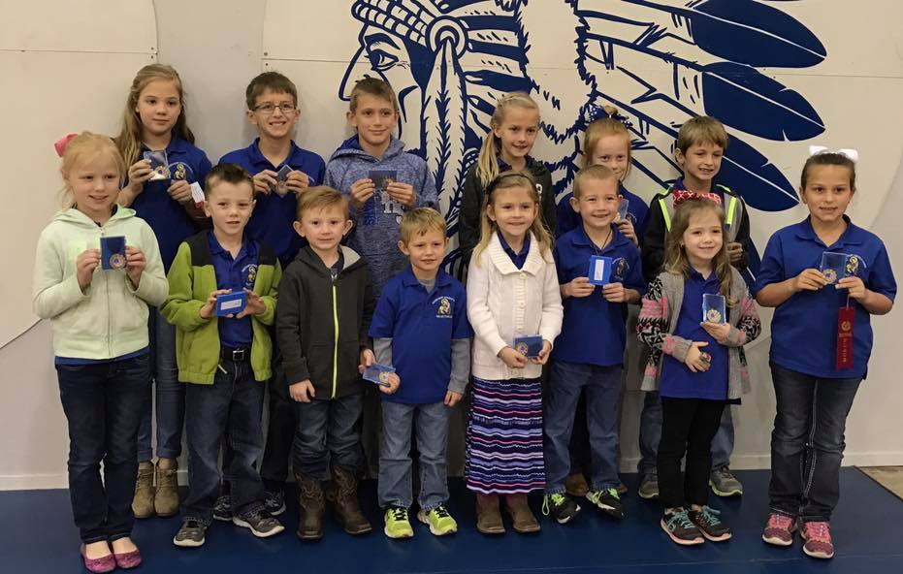
Science Projects Catholic Schools Week Spirit Winners

UPCOMING EVENTS

FALLING LEAVES GALA – Saturday, October 14, 2017, KC Hall, 5:30 – 11:30 p.m., Music by Broken Alibi. $100 per couple - includes dinner, open bar, dance and raffle prizes. For more information or to reserve your ticket, call the KC Hall at 361-798-2311 or email kchall2006@sbcglobal.net. Tickets may be purchased at Sacred Heart Catholic School or on line at http://kchall.com. Proceeds benefit the KC Charities and Sacred Heart Catholic School.

SACRED HEART HOME AND SCHOOL ASSOCIATION STRUDEL BAKE – Saturday, October 21, 2017. See insert for more details.

BAND TAMALE SALE - The Sacred Heart Band Booster Club annual tamale sale begins in early October to mid November. Regular pork, jalapeno and chicken tamales are $10.00 per dozen. They can be purchased from any band member or the school office at 361-798-4251.

BOOSTER CLUB FUDGE SALE – The Sacred Heart Catholic School Booster Club will be selling fudge in November and December. These make great Christmas gifts! Contact Wendy Janak for more information on how to purchase this delicious fudge. 361-798-6259 or email wjanak@leopoldinsurance.com

ANNUAL EXTRAVAGANZA - Sacred Heart Catholic School will be hosting the 16th Annual Extravaganza on Saturday, February 3, 2018, from 6:00 p.m. to 12:30 a.m. at the Knights of Columbus Hall in Hallettsville. All proceeds benefit Sacred Heart Catholic School. The extravaganza will include a social hour, hors d’oeuvres, steak dinner for two, evening dance with live music, raffle, and silent auction. More details will be mailed later.

POLKA FEST – March 23-25, 2018

MARATHON FOR CATHOLIC EDUCATION April 20, 2018

2018 GRADUATION Sunday, May 20, 2018 KC Hall, 4:00 p.m.

SPRING PICNIC – Sunday, May 27, 2018, KC Hall

CLASS REUNIONS – We have a database of Sacred Heart Catholic School alumni. Please call the school at 361-798-4251 or contact Mary Hall with the Sacred Heart Alumni Association: hallstx.com. We can also provide your class with a tour of the campus. Call the rectory at 361-798-5888 to reserve the Family Center. Some classes hold their class reunions in conjunction with homecoming or on the week-end of the Sacred Heart Parish Picnics (the last Sunday in May, or the first Sunday in September.) Please notify the school and the Hallettsville Tribune Herald (361-798-2481) if you are planning a reunion. They will advertise your reunion at no charge.

SACRED HEART CATHOLIC SCHOOL

HOMECOMING ACTIVITIES

Sunday, October 22, 2017, 5:00 p.m.

Pep Rally & Letter Lighting In the School Gym

Thursday, October 26, 2017
Football Game 7:30 p.m.

Sacred Heart Indians vs. Shiner St. Paul
Hallettsville Brahma Memorial Stadium

Saturday, October 28, 2017

Memorial Mass at 3:00 p.m.

To Remember Your Classmates
Sacred Heart Catholic Church

Social & Dinner After the Mass

Chicken fried steak dinner with all the trimmings
Knights of Columbus Hall
Meal Ticket $10.00

Private Homecoming Dance

8:30 p.m. – 11:30 p.m.
Music by: DJ
All Sacred Heart students, alumni, family and
guests are invited. Free will donations accepted.

Intermission - Crowning of Homecoming King and Queen

Graduates of 1952, ‘57, ‘62, ’67, ’72, ’77, ’82, ’87, ’92, ’97, 2002, 2007, 2012, 2017 Will Be Recognized

NEWS AND MORE!

WEBSITE & FACEBOOK PAGE - Keep up to date on all our school activities through our website www.shschool.org and enjoy seeing pictures of all that we are doing on our Facebook page – Sacred Heart Catholic School.

2017 ANNUAL FUND UPDATE – Thank you to everyone who contributed to the 2016-17 Annual Fund. A total of 158 donors contributed $98,686.00. There will be a reception for all donors on Sunday, October 15th. If you donated to the annual fund this year, you will receive an invitation soon. You may still donate to the 2016-17 Annual Fund. Bring your donation by the school (marked Annual Fund) or mail to: Sacred Heart Catholic School Annual Fund, 313 S. Texana St., Hallettsville, TX 77964. We are very grateful for your support of Sacred Heart Catholic School. The 2017-18 Annual Fund will kick-off soon!

MORE ALUMNI NEWS

SACRED HEART ALUMNI ASSOCIATION 2017 DUES - Dues are $20 per year. We awarded a $500 scholarship again this year and will be providing a grant to the tuition assistance program for the school. Please send your annual membership payment to: Kathy Haas, Sacred Heart Alumni Association, 313 S. Texana, Hallettsville, TX 77964. Please include your name (including maiden name), year you graduated, address, phone number, and email address. Thank you for your support of our students. If you have moved, please let us know your new address.

CATHOLIC SCHOOLS SWEEPSTAKES! Sponsored by Catholic Life Insurance – Enclosed are 5 Catholic Schools Sweepstakes raffle tickets. Help support our school by purchasing these raffle tickets ($5.00 each) for the Catholic Schools Sweepstakes. ALL MONIES FROM THE SALES OF THE TICKETS GO IMMEDIATELY TO OUR SCHOOL. Our goal is to sell 10,000 tickets for a net profit of $50,000.00. Over the past seven years since we began the Catholic Life Sweepstakes, we have sold 41,385 tickets for a net profit of $206,925.00. The sweepstakes funds have been and will continue to be used to enhance our staff salaries and support our school general operating fund. We appreciate your support! If you need more tickets, please call the school office. 361-798-4251

ATTENTION ALUMNI -
IT’S STRUDEL BAKE TIME!

DO YOU REMEMBER HELPING MAKE STRUDELS AS A KID? COME AND JOIN US AGAIN ON SATURDAY, OCTOBER 21, 2017 AT THE SACRED HEART CATHOLIC SCHOOL CAFETERIA AND FAMILY CENTER.

WE WELCOME AND ENCOURAGE ALL ALUMNI TO COME AND HELP MAKE THIS PROJECT A SUCCESS. LAST YEAR, WE MADE 2,217 STRUDELS WITH A NET PROFIT OF $29,768.57

THE STRUDEL BAKE ENTAILS MANY JOBS. VOLUNTEERS ARE DESPERATELY NEEDED. THERE WILL BE A JOB FOR EVERYONE THAT COMES TO HELP! EXTENSIVE BAKING KNOWLEDGE IS NOT NEEDED TO VOLUNTEER. EVERYONE IS WELCOME TO PARTICIPATE AND MEN ARE NEEDED AS WELL AS WOMEN. PLEASE BRING YOUR ROLLING PIN FOR ROLLING DOUGH OR PARING KNIFE FOR CORING APPLES. DONATIONS OF SUGAR, SHELLED PECANS AND CASH CAN BE DROPPED OFF AT SCHOOL OR THE RECTORY. WE ARE IN NEED OF SHELLED PECANS.

THE HOME AND SCHOOL ASSOCIATION MEMBERS THANK YOU FOR YOUR SUPPORT!!!

STRUDELS WILL BE SELLING FOR $17.00 BAKED AND $15.00 UNBAKED.
PLEASE PLACE YOUR ORDERS EARLY

IF YOU ARE INTERESTED IN WORKING OR ORDERING STRUDELS THERE ARE SEVERAL OPTIONS:
ONLINE: PLEASE GO TO THE HOME AND SCHOOL ASSOCIATION WEBPAGE
YOU CAN FIND IT AT shschool.org UNDER Contact – Home and School Association.
(http://www.shschool.org/contact/homeschoolassociation.cfm)
EMAIL: shsstrudelbake@gmail.com
CALL: CHARLENE BRADBURY 798-3224, ANNETTE HENKE 798-5374, OR BARBARA GRAHMANN 798-4167
HAND DELIVERY: FILL OUT THE BELOW FORM AND RETURN IT TO THE SCHOOL
-------------------------------------------------------------------------------------------------------------------------------

ANY AMOUNT OF TIME YOU CAN GIVE WILL BE APPRECIATED.

I CAN WORK SATURDAY, OCTOBER 21, 2017

________ 7:00 AM TO 10:00 AM
________10:00 AM TO 1:00 PM
________ 1:00 PM TO 4:00 PM

_______ I WILL DONATE CASH, AMOUNT_________(PLEASE ATTACH TO THIS SLIP)
_______ I WILL DONATE SUGAR, AMOUNT_________LBS. (800 LBS SUGAR NEEDED)
_______ I WILL DONATE SHELLED PECANS. AMOUNT________ (200 QTS OF PECANS NEEDED)
_______ I WILL DONATE ONE BOX OF APPLES. $30.00

I WILL ORDER ____________ UNBAKED (NO SPECIAL ORDERS).
____________ BAKED STRUDELS (NO SPECIAL ORDERS).

Phone #_______________________

Cell #_________________________ _______________________________________
PRINT NAME
Email:_____________________________________________

