December 2025

Sun | Mon | Tue | Wed | Thu | Fri | Sat
 | 1  Waffle  Hash Brown  Sausage Patty  Yogurt  Milk | 2  Chicken Nuggets  Mac n Cheese  Mixed Vegetables  Fruit  Milk | 3  Meatball Sub  Tatar Tots  Corn  Fruit  Milk | 4  Beef Stew  Buttered Potatoes  Green Beans  Roll  Fruit  Milk | 5  BBQ Sandwich  Pickle Spear  Chips  Cookie  Milk | 6
7 | 8  Scrambled Eggs  Bacon  Biscuit w/Jelly  Apple Juice  Milk | 9  Taco Nachos  Lettuce  Cheese  Tomatoes  Pinto Beans  Jello | 10  Steak Fingers  Mashed Potatoes  Green Beans  Fruit  Milk | 11  Spaghetti  Garlic Cheese Stix  Corn  Fruit  Milk | 12  Chicken Burger  Pickles  Fries  Italian Ice  Milk | 13
14 | 15  Fettuccine Alfredo  Bread Stick  Salad  Fruit  Milk | 16  Pigs in Blanket  Mac n Cheese  Ranch Style Beans  Fruit  Milk | 17  NO CAFETERIA  SERVICE  DISMISS AT  12:00 NOON | 18  NO CAFETERIA  SERVICE  DISMISS AT  12:00 NOON | 19  NO CAFETERIA  SERVICE  DISMISS AT  12:00 NOON | 20
21 | 22  Christmas  Break | 23  Christmas  Break | 24  Christmas  Break | 25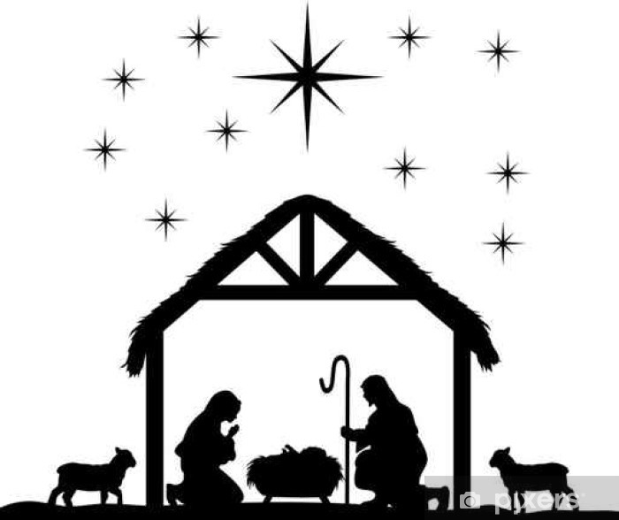 | 26  Christmas  Break | 27
28 | 29 | 30 | 31

HAVE A BLESSED CHRISTMAS

