Sacred Heart Catholic School
SPREADING GOD’S LOVE SINCE 1882

The Mission of Sacred Heart Catholic School is to teach Gospel values that will foster the spiritual,
moral, academic, social, and physical growth of the students according to Catholic tradition
and the spirit of the Sisters of the Incarnate Word and Blessed Sacrament.

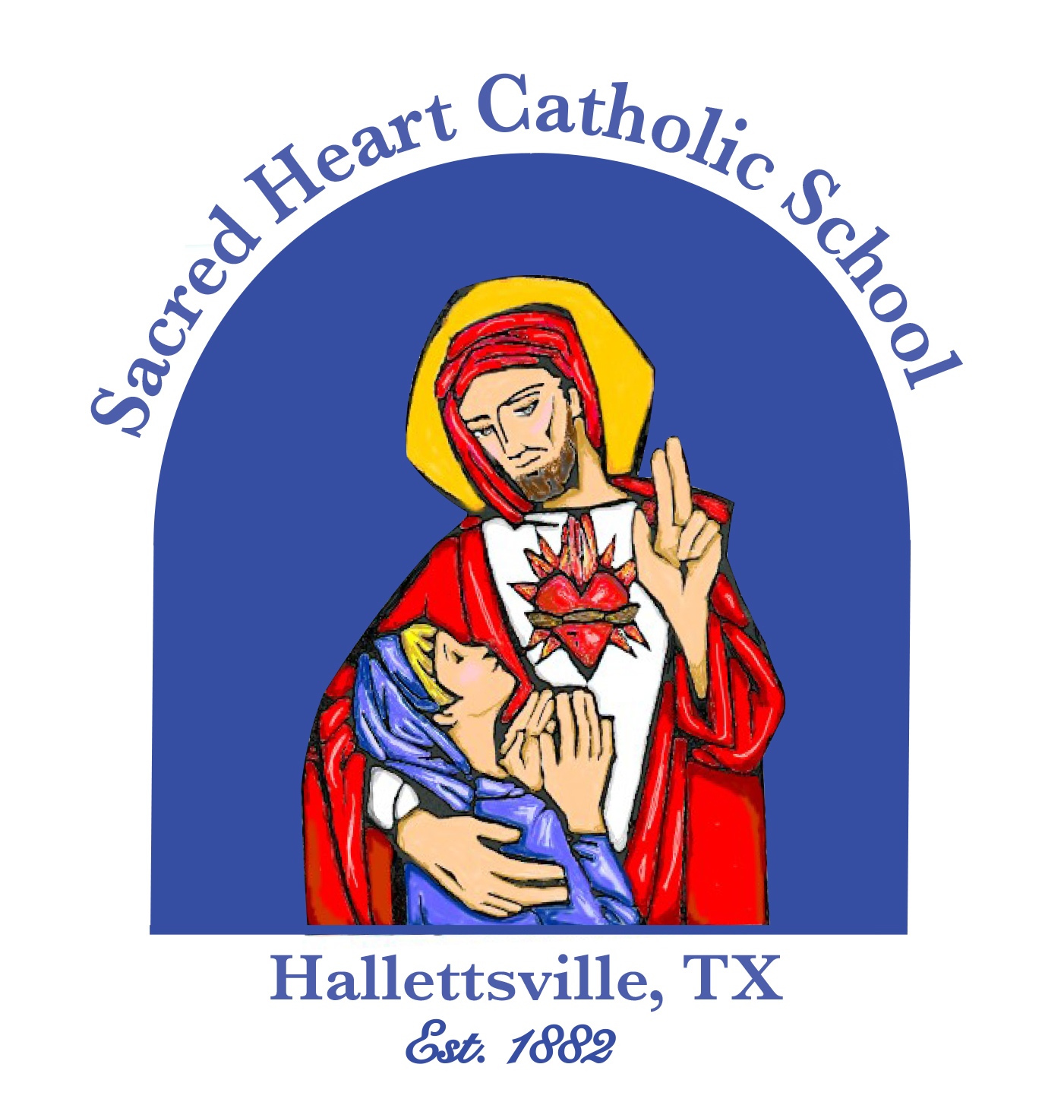

361-798-4251 313 S. Texana St., Hallettsville, TX 77964 www.shschool.org

GOOD NEWS BULLETIN

May 2025

NOTICES!

EARLY DISMISSALS
May 2nd - 2:00 p.m.; All grades; Faculty meeting
May 19th - 20th – High School:12:00
May 19th – 20th - Pre K – 8th : 2:00
May 21st – Pre K – 12th
Dismissal at 12:00; No extended care
May 23rd - 9:30, Last day

NO CLASSES- Thursday, May 22nd - Teacher work day

SENIOR BACCALAUREATE
Sunday, May 11th, 10:30 mass

GRADUATION – Sunday,
May 18th , 3:00 p.m.; KC Hall

SUMMER HOURS – In June: Monday - Thursday, 9:00 - 2:00;
July – call the school; 361-798-4251

FROM THE PRINCIPAL’S DESK
What a fast year it has been. The year is quickly wrapping up and will be moving on to summer! It has been an extremely busy spring with a lot of great things going on at our school. Congratulations to the High School Band for placing 3rd at the TAPPS State Band Competition in Waco. We also had many students participating in Art and Academics. They have been putting forth the efforts to be very successful this year! Graduation 2025 is around the corner as we bid farewell to the 23 graduates. Graduation time will be at 3:00 so be sure to mark your calendars. Many of our seniors spent 13 years at SHS and some started as babies when the daycare was in operation. They have had some great experiences here. These awesome students are well prepared for their next steps into the future. I pray that the educational and faith foundation they received at Sacred Heart Catholic School will lead them to future successes. We wish these 23 students the best of luck. May God bless them in their future endeavors! Thank you to everyone who helped make our annual Marathon a huge success. The Marathon brings in over $20,000 annually and assists with the school budget in a variety of ways. The funds have been used for AC replacements, additional curriculum assistance, technology needs, and other school repairs. It was wonderful to see so many parents helping. The Marathon tradition has continued for over 35 years. It is wonderful to keep it going to celebrate our great Catholic School!

STUDENT ACHIEVEMENTS

CONGRATULATIONS 2025 SENIORS – Lance Barton, Sam Bludau, Ainsley Brocker, Annika Brooks, Brianna Clark, Riley Haas, Bralen Heger, Abigail Hill, Karley Kostelnik, Mary Beth Krischke, Hudson Kutac, Kellen Mechura, Mallory Mueller, Kaycee Schindler, Emma Schmidt, Marcus Seger, Andrew Steffek, Joshua Terry, Adyson Trobl, Laura Varela, Harley Wilson, Heather Wilson

DISTRICT TRACK RESULTS - Girls: 3rd Place Overall; Mallory Mueller -- 1st High Jump; Rylan Dworsky - 2nd Triple Jump; Karley Kostelnik - 3rd Discus 91' 8", 4th Long Jump, Mary Beth Krischke - 1st 3200m, 2nd 1600m; Emma Schmidt - 2nd 800m , 3rd 400m; Kenzie
Chance - 3rd 100m; Catherine Lemonds - 3rd 300m Hurdles 54.66, 1st - 4x100m Relay: Karley Kostelnik, Rylan Dworsky, Kenzie Chance, Catherine Lemonds; 3rd – 4x200m Relay: Karley Kostelnik, Rylan Dworsky, Kenzie Chance, Zoie Hernandez; 3rd – 4x400m Relay: Karley Kostelnik, Catherine Lemonds, Rylan Dworsky, Emma Schmidt; Boys: 1st Place; Boys District Track Results: 100 meters: 2nd Clayton Haas, 7th Emerson Harvey, 9th Jaxson Eggemeyer; 400 meters: 5th Kolby Haas, 8th Brennen Ralston, 10th Jaxson Eggemeyer; 200 meters: 9th Emerson Harvey, 10th Cameron Cull; 16th Arlen Henke; 4 x 100 Relay 2nd Place: Cameron Cull-Andrew Steffek-Layne Sevcik-Clayton Haas; 4 x200 Relay 1st Place : Cameron Cull-Andrew Steffek-Layne Sevcik-Clayton Haas; 4x 400 Relay 2nd Place: Trent Sevcik-Andrew Steffek-Layne Sevcik-Kolby Haas; 3200 meters - 2nd Ryan Janak, 10th Ben Meinkowsky; 1600 meters - 2nd Ryan Janak; 7th Ty Lewis; 9th Ben Meinkowsky; Long Jump- 1st Layne Sevcik, 2nd Clayton Haas, 8th Emerson Harvey; Triple Jump - 2nd Trent Sevcik, 6th Brennen Ralston, 9th Arlen Henke; High Jump - 5th Kolby Haas, 5th Brennen Ralston; 800 meters - 3rd Ty Lewis, 4th Marcus Seger; Shotput - 4th Andrew Steffek, 10th Brock Seger, 14th Lance Barton; Discus - 5th Lance Barton, 7th Brock Seger; 300 Hurdles - 1st Trent Sevcik

LAVACA SOIL & WATER CONSERVATION CONTEST RESULTS – School: Essays – Age 13 and Under: 1st Place– Edward Lee Kubenka; 2nd Place –Aiden Steffek; 3rd Place– Kristina Rybak; School: Essays – Age 14 & older: 1st Place – Ainsley Grahmann; Posters 3rd – 6th Grades: 1st Place Avery Lewis; 2nd Place Gage Grahmann; 3rd Place Brantley Steffek; District: Posters 3rd – 6th Grades– 1st Avery Lewis; Essays Ages 13 & Under: 2nd Edward Lee Kubenka; Ages 14 & older – 1st Ainsley Grahmann

CONGRATULATIONS 2025-2026 CHEERLEADERS High School: Caroline Bartek, Layne Besetzny, Kenzie Chance, Allison Clark, Ainsley Grahmann, Chloe Grahmann, Kayla Kurtz, Kenzie Kurtz, Mabry Machac, Catherine Lemonds, Kinley Migl, Landyn Migl, Ainsley Noska, Lacie Olivarez, Jillian Whited, Kenney Zappe Junior High: Emma Beach, Max Collins, Amryn Etzler, Haley Hartensteiner, Kallie Loudon, Zoe Machicek, Emi Pohl, Kenley Sevcik

CONGRATULATIONS TO OUR SWIM TEAM: Academic All State: Annika Brooks, Ryan Janak, Karley Kostelnik, Ty Lewis

STATE PSIA RESULTS: 3rd grade: Emmalee Pastucha – 5th place in Number Sense; 4th grade: Claire Janak – 3rd place in Maps, Graphs, and Charts, 3rd place in Ready Writing; 7th grade: Konnor Chance – 2nd place in Number Sense; Lily Janak – 4th place in Maps, Graphs, and Charts;
Emi Pohl – 3rd place in Ready Writing, 3rd place in Spelling, 6th place in Maps, Graphs, and Charts; Ethan Tumamao – 6th place tie in Listening Skills; 8th grade: Rafael Varella – 5th place tie in Maps, Graphs, and Charts

…...NEWS….NEWS….NEWS….NEWS….NEWS…...

2025-2026 REGISTRATION - Registration forms are on our website.
www.shschool.org Go to the Admissions tab and click on Registration Forms.

BAND NEWS - SHS Band Spring Concert, Tuesday, May 13th, 6:30 p.m. in the gym.

SHCS ALL AWARDS BANQUET - The Sacred Heart Catholic School Annual All-Awards Banquet will be held on Monday, May 12th, at 6:30 p.m. at the Hallettsville K.C. Hall. Serving begins at 6:00. Tickets are $13.00 each and may be purchased at the school office. Deadline to purchase tickets is Friday, May 2nd at noon. NO TICKETS will be sold at the door.

BOOSTER CLUB FRIED CHICKEN SUPPER - The SHS Booster Club annual fried chicken supper will be held on Wednesday, May 7th from 4:30 – 6:00 p.m. at the KC Hall. Tickets are $13.00

5th GRADE ST. JUDE MATH-A-THON RAISES $2,505.00 Thank you to everyone who donated to help support St. Jude Children’s Research Hospital which helps children who are battling cancer and other illnesses. We appreciate your generosity!

BLOOD DRIVE – Wednesday, May 7th, 10:30 – 6:00, Family Center

ADVISORY COUNCIL ELECTIONS – May 17th & 18th after all the masses

COUNSELOR’S CORNER

2025 SAT TEST DATES: May 3rd ; June 7th;
To register, go to www.sat.org/register;
2025-2026 Test Dates: Aug. 23rd; Sept. 13th; Oct. 4th; Nov. 8th; Dec. 6th; March 14th; May 2nd; June 6th

2025 ACT TEST DATES: June 14th, July 12th
To register, go to: www.actstudent.org
2025-2026 Test Dates: Sept. 6th, Oct. 18th, Dec. 13th, Feb. 14th; April 11th, June 13th, July 11th

TSIA TEST – All students planning to take dual credit classes next year must take the Texas Success Initiative Assessment (TSIA) and meet the minimum score requirements, unless they are eligible through their PSAT scores. The cost is $15.50.
Go to: http://www.victoriacollege.edu/tsiassessment
Students receive their results immediately and will know if they met the minimum required scores on each of the tests – reading, writing, & math.

MAY BIRTHDAYS

1 Titus Lee
Mrs. Charlene Pillow
2 Avery Beach
Annika Brooks
3 Ava Shimek
4 Allen Ballard
Lance Barton
Granger Clark
5 Audrie Jasek
6 Johanna Jansky
Mallory Mueller
Emmalee Pastucha
11 Thayer Krischke
12 Claire Steffek
13 Rhett Kahn

MAY ANNIVERSARIES
May 5th - Coach Rodney & Kay Dowell

MAY ANNIVERSARIES

14 Logan Etzler
16 Hannah Haas
17 Timber Janak
19 Lauren Bludau
Deacon Lution Hill
20 Tatum Beach
Harrison Kahn
Joshua Terry
21 Easton Brown
23 Mrs. Debi Bludau
24 Gage Grahmann
25 Caroline Hartensteiner
27 Justin Curtis
28 Chase Sturrock
30 Bowen Brewer

SACRED HEART CHURCH PICNIC

SUNDAY, MAY 25TH, KC HALL
Fried chicken and stew lunch
Live music and games; Live auction 

A PRAYER FOR MOTHERS
Lord God, we thank you for the gift of mothers, for their love, their strength, and their unwavering devotion. On this Mother's Day, we ask for your blessings upon all mothers, especially those who have given us life and nurtured us with love. May they be filled with joy, peace, and grace as they continue to guide and support their families.
We also remember Mary, the Mother of Jesus, and ask for her intercession for all mothers. May her example of faith, love, and obedience inspire them to live lives of service and holiness.
Grant to all mothers the strength to face challenges, the wisdom to make wise decisions, and the grace to raise their children in faith. May they always know your love and protection.
We ask this through Christ our Lord. Amen.



