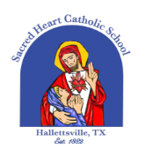
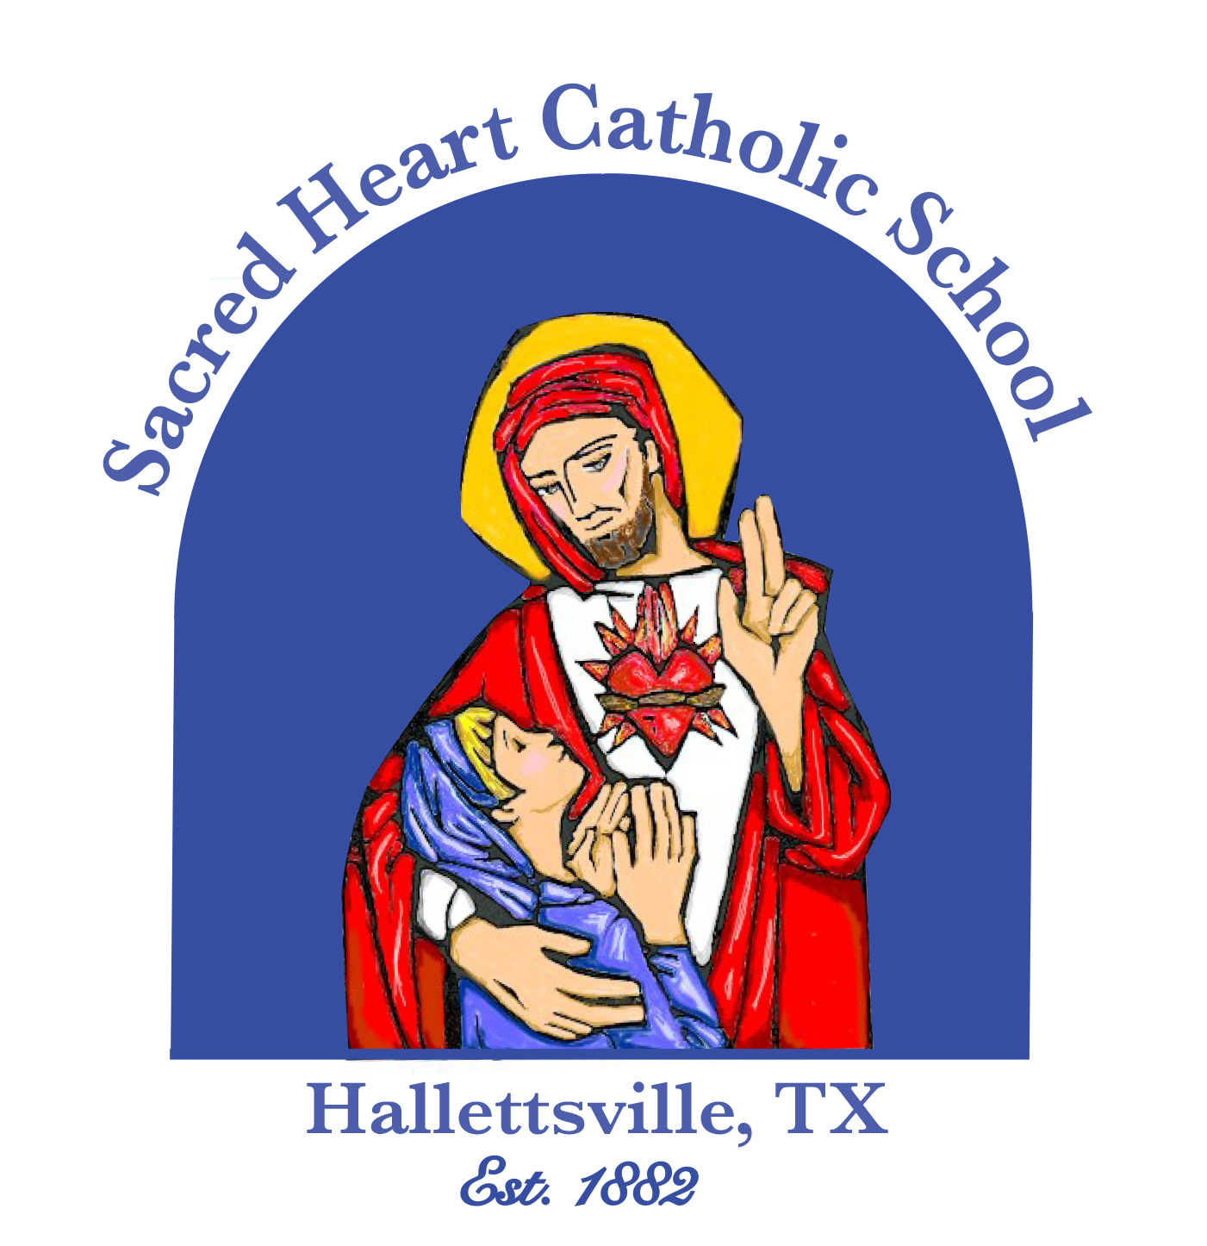

Sacred Heart Catholic School

SPREADING GOD’S LOVE SINCE 1882

313 S. Texana St.,
Hallettsville, TX 77964
361-798-4251
www.shschool.org



Family Newsletter ~ September 2025

DUAL CREDIT CLASSES – Students who are taking dual credit classes need to check their Victoria College Pirate Portal for messages or updates. To set up their Pirate Portal, students need to go to: https://victoriacollege.edu/Explore/GettingStarted/Registration Click on “Pirate Portal” which takes them to a link where they can set up their Pirate Portal.

COUNSELOR – Karen Mudd
karen.mudd@shschool.org

News to Know……………………………

2025 Fall Parish Picnic The picnic is on Sunday, August 31st. We need YOUR help! Students and parents – please donate your time and help out. The Church donates so much money to the school to help keep tuition as low as possible. We want to make sure we do our part, so please, show up and help out. “For it is in giving that we receive…” ~ St. Francis of Assisi

NO SCHOOL – Monday, September 1st , Labor Day holiday

School Pictures – School pictures will be on Wednesday, September 3rd .

SHS Booster Club Meeting – Monday, September 8th and Wednesday, September 24th at 6:00 p.m. in the Hall of Fame Room at the Knights of Columbus Hall. Everyone is welcome, and we highly encourage new families to join us!

Early Dismissal – Friday, September 5th @ 2pm. Faculty Meeting

25/26 Yearbook – The Phoenix yearbook can still be ordered. The cost is $80.00.

Progress Reports – September 12th is the end of the 4 ½ week grade period for the first nine weeks. Progress reports will be distributed on September 15th.

Kindergarten Grandparents’ Day – The Kindergarten class would like to invite their grandparents to attend Mass with them on Friday, September 5th at 8:05am followed by a reception afterwards in the Family Center. Grandparents may also visit the classroom.

Don’t Miss The News – Remind is the texting system used to notify and remind parents of upcoming events or school emergencies; Messages are sent via text, enter this number to text to: 81010, then text this message: @869fkk

FROM THE PRINCIPAL’S DESK

We are all back at it again and things are going great at Sacred Heart! August was an exceptional start to the new year, and we continue to see God’s blessings unfold daily as our students grow in knowledge, faith, and community. We welcome our new students and their family to Sacred Heart School. We are very blessed with some new staff members as well. It’s amazing to see so many new faces come together to make up our Sacred Heart family. We welcome 21 new families and 10 new staff members. Our enrollment has increased to 326 for an increase for the 7th year in a row. This makes a total of 179 families. Please do all you can to welcome our new family members.
As the new year begins, there are a few things that we want to work on this year which includes our overall communication, security and faith based campus ministry. We plan on increasing our communication provided by emails, text, facebook and SportYou App. Additionally, we have continued efforts to increase our safety on campus for your students. And finally, our overall campus ministry will provide for confessions more regularly for students and also use a new program called “Education in Virtue - A Way of Life for all levels to understand the Christian virtues and a way to practice holiness of life. We want to incorporate this in our daily school routine and hopefully you can use it at home as well. Our goal is to continue to make Sacred Heart better and better every year! We welcome you and your family to join in with all the excitement we have here at Sacred Heart Catholic School!
~Kevin Haas
Counselor’s Corner

Karen Mudd, SHS Counselor
Email karen.mudd@shschool.org

2025 - 2026 SAT TESTS: Sept. 13th, Oct. 4^{th,}Nov. 8^{th,} Dec. 6^{th,} March 14^{th,} May 2^{nd,} June 6^{th,} The following tests are offered at HHS; Sept. 13th and May 2nd
To register, go to: www.sat.org/register For practice tests, go to https://www.khanacademy.org/

2025-2026 ACT TESTS: Sept.6th, Oct.18th, Dec. 13th, Feb. 7th, April 4th, June 13th, July 18th
To register, go to: www.actstudent.org

UPCOMING MEETINGS in FAMILY CENTER:
Junior Parent Meeting – September 15th @6:00 p.m
Sophomore Parent Meeting – September 29th @6:00 p.m.

2026 SENIORS: Some college applications opened in July. Check the websites of the colleges that you want to apply to and find out when their applications open. If you need a transcript sent, email Karen Mudd.

DUAL CREDIT CLASSES – Students who are taking dual credit classes need to check their Victoria College Pirate Portal for messages or updates. To set up their Pirate Portal, students need to go to: https://victoriacollege.edu/Explore/GettingStarted/Registration Click on “Pirate Portal” which takes them to a link where they can set up their Pirate Portal.

COUNSELOR – Karen Mudd
karen.mudd@shschool.org

AREA SUPPORT AGENCIES

The following agencies provide support and/or counseling services for students and families.

The Emmaus Center – Victoria; Provides Catholic-based professional counseling for the faithful of the Diocese of Victoria and others seeking Christian-based counseling. Services are available for individuals, couples, and adolescents. 361-212-0830

Gulf Bend Center, Victoria; improve the quality of life of persons and their families who are challenged with problems related to mental illness and intellectual and developmental disabilities. 361-575-0611 or use the
24 Hour Crisis Hotline 877-723-3422 in an emergency.

Mid-Coast Family Services, Victoria; works to empower individuals to live a life free of family violence, homelessness, sexual assault, and substance abuse. 24 Hour Domestic Violence Hotline: 361-573-HELP or 800-870-0368

Norma’s House, Hallettsville; Helps children who are victims of physical, emotional, sexual abuse, and neglect; To report suspected child abuse, call 800-252-5400 or 911

Turtle Wing Foundation, Schulenburg; Mission: to help children in rural areas with learning challenges achieve their full potential. 979-505-5090

Important News from TAPPS

Fan, Coach, & Athlete Behavior – Removal from Contest/Rushing the Field, Court or Pitch

As we look ahead to a new year of competition and in keeping with our motto, “Competition with Honor”, the TAPPS Executive Board has unanimously approved the following penalties in the cases of a coach, athlete or fan being removed from an athletic contest. In addition, the Board has addressed the issue of fans rushing the field, court or pitch. The following are in place for the 2024-25 school year:
Removal from Contest:
- Student fan – school is fined $100 ($200 during playoffs)
- Non-Student Fan – school is fined $250
- Player – 1 game suspension (1st half of next game in football) and a $100 fine ($200 fine for playoffs)
- Coach – 2 game suspension (1 game in football), public reprimand and a $300 fine ($500 fine for playoffs)
- After 3 ejections (player or coach) in a sport/5 ejections as a school
In addition to a required meeting by the coaches and AD with TAPPS, the AD will receive a public reprimand and probation.

Fans rushing the field/court/pitch at the buzzer with no incident (players and officials no longer on the court):
- First Offense – warning
- Second Offense – $1500 fine
- Third Offense – $1500 fine and no fans at next game

Fans rushing the field/court/pitch at the buzzer with players and officials still on the court:
- First Offense – $1500 fine
- Second Offense – $1500 fine and no fans at next game
- Third Offense – Additional sanctions to be determined by TAPPS https://tapps.biz/removal-from-contest/
https://tapps.biz/removal-from-a-contest-2/


Monthly Newsletter – Now in Email Form!

Beginning with Sept. 2025, we will mail the newsletter to your home AND email it to you, provided we have your contact information.

You can also access the newsletter on the website!
Click on ACTIVITIES And then select “monthly newsletters”

19 Ms. Rachel Cervenka
20 Klein Belcik
Levi Opela
21 Jarrett Jansky
22 Mrs.Wanda Orsak
23 Max Collins
Mrs. Misti Ridgeway
25 Mrs. Brenda Etzler
26 Coach Kellie Haas
Mr. Mike Lemonds
27 Luke Meinkowsky
Rhett Holliday
28 Caston Zidek
29 Brynadee Etzler
Ford Opela
Tenley Zbranek
30 Mrs. Karen Mudd
Rowan Kedziora

Need more information?

Student & Staff August Birthdays

4 Greysen Miranda 19 Ms. Rachel Cervenka
5 Philip Bochat 20 Klein Belcik
6 Ezra Lucas Levi Opela
7 Caston Dworsky 21 Jarrett Jansky
8 Clare Lemonds 22 Coach Wanda Orsak
9 Lace Zidek 23 Max Collins
11 Kenzie Chance 25 Mrs. Brenda Etzler
Trent Ferry 26 Coach Kellie Haas
Ainsley Noska Mr. Mike Lemonds
Bransen Pastucha 27 Rhett Holliday
Mrs. Taylor Bochat Luke Meinkowsky
12 Juliana Henke 28 Caston Zidek
13 Grayson Whited 29 Ford Opela
14 Mrs. Stella Myers Brynadee Etzler
15 Addisyn Mozisek Tenley Zbranek
17 Macie Haas 30 Rowan Kedziora
Claire Janak Mrs. Karen Mudd
18 Emma Drozd
Kayla Kurtz
Kenzie Kurtz
Emi Pohl

Reminders
Attendance and Absence - Students are expected to be present and punctual for all classes throughout the year. Parents are asked to email attendance@shschool.org and call 361-798-4251. After an absence, students must obtain an Admission Slip from the office permitting them to return to class.
NO ALCOHOL, SMOKING, E-CIGARETTES, OR USING TOBACCO PRODUCTS AT SCHOOL RELATED ACTIVITIES –
All athletic and academic contests are school activities, so the use of alcohol or tobacco, in any form, is prohibited. This is a violation of state rules set by the Texas Education Agency and in violation with our code of conduct. This applies to students AND fans at any event where our students are involved.
PERMISSION TO LEAVE SCHOOL DURING THE DAY – Sacred Heart Catholic School operates a closed campus policy. Students must remain on the school grounds from arriving, even if the first period has not yet begun, until dismissal. Students are not permitted to leave the school grounds without permission from the office. A student who needs to leave campus must present a written request, signed by a parent or guardian, to the principal before the first period begins in order to be allowed to leave the campus. When the request to leave has been approved, the student will sign out on the required form located in the school office. Should the student return to the school during the same day, he/she must sign in and receive a permit to return to class.
RAPTOR SYSTEM - PARENTS/VISITORS SIGN IN– All visitors and parents are welcome at Sacred Heart Catholic School and are required to sign in at the school entrance when coming on campus. IDs will be required for everyone. Signs to that effect have been posted at all entrances. Please sign out also when leaving the campus.
All deliveries of items, messages, or lunches for students or staff must be dropped off at the front entrance office of the school. They will be delivered to the designated person at the appropriate time by school personnel. The purpose of this policy is to provide security and safety for your children and to avoid unnecessary interruptions of classroom instruction.
Please remember to email the teacher/staff member, in advance, to make an appointment when you need to confer with a teacher, counselor, or administrator.

